Towards an Implementation of DOI Application Profiles within the Handle System:
A hierarchical architecture for DOI infrastructure

Tony Hammond - 13.12.00

The purpose of this document draft is to lay out a strawman proposal for how DOI application profiles can be implemented through the Handle system. The essence of organizing DOI applications is to identify each application profile with an administrative DOI and to populate its value set with profile-specific data values, such as DOI kernel and application metadata lookup services, etc. Each application DOI (ie those identifying an item of intellectual property) is also given one (or more) values which identify the profile(s) for the applications which service that DOI.

A generalized (and extensible) hierarchical DOI infrastructure is defined which is rooted in a master DOI service registry <doi:10/10> which maintains entries for individual service registries which maintain service elements such as DOI agents, application profiles, clients and handle types, etc. All administrative DOIs are linked to their parent objects (registries), while each application DOI is linked into the infrastructure through its application profile. All DOIs are thus interlinked within the DOI handle application.

Principles include following standard handle naming practices, while also defining a coherent set of handle types specifically for DOI to avoid collisions with other handle applications. DOI handle types are either of base type “URI” or “String Literal” – this is consistent with the Resource Description Framework model. A full RDF description of DOI application profiles should be (relatively) easy.

All DOIs cited in this document are given in standard URI format and are “actionable” through the YAHC handle client which provides a complete simulation of the proposed handle types through its Virtuality feature. This allows for rapid prototyping of a multiple resolution framework for DOI.

Architecture highlights:

- Every DOI (application and administrative) has one or more associated application profiles.
- All DOI handles are interlinked within the DOI handle application.
- The DOI handle application is a self-contained implementation within the Handle system and is independent of other handle applications and intentions (eg handle type semantics).
- XAD - An eXtensible API for DOI is required. A preliminary is given.

Contents

DOI Infrastructure Overview

DOI Handle Types

DOI Application Profiles

DOI Master Registry for DOI Service Registries

DOI Agent Registry

DOI Application Profile Registry

DOI Client Registry

DOI Type Registry

Profiled DOI Instances
- XAD – An eXtensible API for DOI

1. DOI Infrastructure Overview

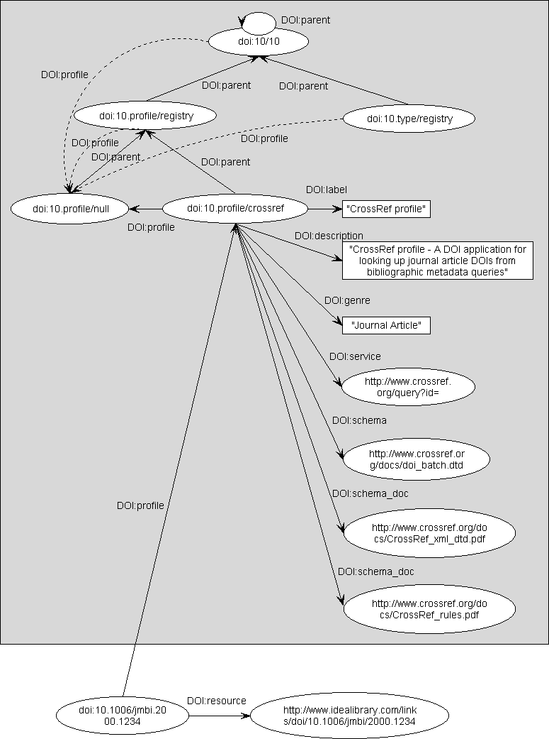

2. DOI Handle Types
A consistent approach to implementing handle types for DOI handle values is proposed. All DOI handle types are prefixed with a "DOI:" namespace identifier to prevent collisions with other handle types and are registered within the handle system as handle types under the "0.type" handle naming authority. Coresponding handles for each DOI handle type are defined under the DOI naming authority "10.type" and this registry <doi:10.type/registry> is entered into the master DOI service registry <doi:10/10>. The reason for the double registration both as native handle types and as DOI handle types is to organize the DOI handle application as a self-contained application within the handle system. The DOI handle types are coordinated within the DOI handle type registry and given a semantic binding.

The following DOI handle types are used in this document:

DOI:agent # URI
DOI:alias # URI
DOI:child # URI
DOI:client # URI
DOI:description # String Literal
DOI:genre # String Literal
DOI:label # String Literal
DOI:parent # URI
DOI:profile # URI
DOI:resource # URI
DOI:schema # URI
DOI:schema_doc # URI
DOI:service # URI
DOI:type # URI

As the DOI handle types are registered both as native handles and as DOI handles the following broad handle type equivalences hold:

hdl:0.type/DOI:agent = doi:10.type/agent
etc.

except there is a semantic binding for the DOI handle types.

Note that all DOI handle types are either of base type “URI” or “String Literal” – this is consistent with the Resource Description Framework model. String literal values may well prove to be of utility in visualization contexts either for navigation or for menu pop-ups.
3. DOI Application Profiles

All DOI type handles are associated with one or more DOI application profiles depending upon the applications that can service them. Each application has its own specific metadata set which is built on top of the DOI kernel set. A DOI which only has kernel metadata is assigned a base application profile, otherwise it is assigned an application specific profile. The only DOI application defined at this time is the CrossRef application and a CrossRef application profile can thus be defined. A zero application profile has also been defined for legacy DOIs which have no associated metadata. (See the DOI Handbook for further information on DOI application profiles.)

One architecture for associating DOIs with DOI application profiles is to identify the application profiles and related services with administrative DOIs. To distinguish these administrative DOIs from application DOIs (ie those identifying an item of intellectual property) we assign them a null application profile. The null application profile is quite distinct from the zero application profile and marks off any such DOIs as being purely administrative. All DOI application profiles are registered with a DOI application profile registry also identified by a DOI. The application profile registry <doi:10.profile/registry> in turn is entered into the master DOI resource registry <doi:10/10>.
4. DOI Master Registry for DOI Service Registries

Description: The DOI master registry which manages all registries registered with the DOI handle application.

doi:10/10

DOI:label | DOI master registry
DOI:description | The DOI master registry which manages all registries registered with the DOI handle application.
DOI:profile | doi:10.profile/null
DOI:parent | doi:10/10
DOI:child | doi:10.agent/registry
DOI:child | doi:10.client/registry
DOI:child | doi:10.profile/registry
DOI:child | doi:10.type/registry

5. DOI Agent Registry

Description: A registry for DOI registration agents.

doi:10.agent/registry

DOI:label | DOI agent registry
DOI:description | Master registry for registered DOI agents.
DOI:profile | doi:10.profile/null
DOI:parent | doi:10/10
DOI:child | doi:10.agent/idf
DOI:child | doi:10.agent/pila

Description: Listed below are the DOIs for the individual DOI agents entered into the registry. Note that the value set could be extended to include POC details or more mundane data such as address, tel/fax numbers which would allow automated systems to reveal such contact information about the registration agency for any digital object.

doi:10.agent/idf

DOI:label | IDF
DOI:description | Default DOI agent – the International DOI Foundation.
DOI:profile | doi:10.profile/null
DOI:parent | doi:10.agent/registry
DOI:resource | http://www.doi.org

doi:10.agent/pila

DOI:label | PILA
DOI:description | Publishers International Linking Association.
DOI:profile | doi:10.profile/null
DOI:parent | doi:10.agent/registry
DOI:resource | http://www.crossref.org

6. DOI Application Profile Registry

Description: A registry for DOI application profiles.

doi:10.profile/registry

DOI:label | DOI profile registry
DOI:description | Master registry for registered DOI application profiles.
DOI:profile | doi:10.profile/null
DOI:parent | doi:10/10
DOI:child | doi:10.profile/null
DOI:child | doi:10.profile/zero
DOI:child | doi:10.profile/base
DOI:child | doi:10.profile/crossref

Description: Listed below are the DOIs for the individual DOI application profiles entered into the registry

doi:10.profile/null

DOI:label | Null profile
DOI:description | Null profile - The null DOI application profile for administrative DOIs.
DOI:profile | doi:10.profile/null
DOI:parent | doi:10.profile/registry
DOI:genre | Void

doi:10.profile/zero

DOI:label | Zero profile
DOI:description | Zero profile - A DOI application profile for legacy DOIs with no kernel metadata.
DOI:profile | doi:10.profile/null
DOI:parent | doi:10.profile/registry
DOI:agent | doi:10.agent/idf
DOI:genre | Any

doi:10.profile/base

DOI:label | Base profile
DOI:description | Base profile - A DOI application profile for DOIs with only kernel metadata.
DOI:profile | doi:10.profile/null
DOI:parent | doi:10.profile/registry
DOI:agent | doi:10.agent/idf
DOI:genre | Any
DOI:service | http://dx.doi.org

doi:10.profile/crossref

DOI:label | CrossRef profile
DOI:description | CrossRef profile - A DOI application profile for the CrossRef application which looks up journal article DOIs from bibliographic metadata queries.
DOI:profile | doi:10.profile/null
DOI:parent | doi:10.profile/registry
DOI:agent | doi:10.agent/pila
DOI:genre | Journal Article
DOI:service | http://www.crossref.org/query?id=

7. DOI Client Registry

Description: A registry for DOI clients. The need for this may not be readily apparent but it may be useful to have a register for charting resources with DOI client capabilities (as distinct from the simpler handle clients) as well as maintaining authority control. Candidate clients may include inter alia servers of the SFX type. This could form the basis of client ‘forwarding’ which addresses the ‘appropriate client’ problem.

doi:10.client/registry

DOI:label | DOI client registry
DOI:description | Master registry for registered DOI clients.
DOI:profile | doi:10.profile/null
DOI:parent | doi:10/10
DOI:child | doi:10.client/doi_proxy
DOI:child | doi:10.client/hdl_gateway
DOI:child | doi:10.client/yahc

Description: Listed below are the DOIs for the individual DOI clients entered into the registry

doi:10.client/doi_proxy

DOI:label | DOI Proxy
DOI:description | Default DOI client – the ‘DOI Proxy Server’.
DOI:profile | doi:10.profile/null
DOI:parent | doi:10.client/registry
DOI:service | http://dx.doi.org

doi:10.client/hdl_gateway

DOI:label | Handle Gateway
DOI:description | Handle gateway client.
DOI:profile | doi:10.profile/null
DOI:parent | doi:10.client/registry
DOI:service | http://hdl.handle.net

doi:10.client/yahc

DOI:label | YAHC
DOI:description | Yet Another Handle Client.
DOI:profile | doi:10.profile/null
DOI:parent | doi:10.client/registry
DOI:service | http://www2.harcourt-international.com/~tony/yahc

8. DOI Type Registry

Description: A registry for DOI handle types. This is required for semantic integrity across the DOI handle application.

doi:10.type/registry

DOI:label | DOI type registry
DOI:description | Master registry for registered DOI handle types.
DOI:profile | doi:10.profile/null
DOI:parent | doi:10/10
DOI:child | doi:10.type/agent
DOI:child | doi:10.type/alias
DOI:child | doi:10.type/child
DOI:child | doi:10.type/client
DOI:child | doi:10.type/description
DOI:child | doi:10.type/genre
DOI:child | doi:10.type/label
DOI:child | doi:10.type/parent
DOI:child | doi:10.type/profile
DOI:child | doi:10.type/resource
DOI:child | doi:10.type/schema
DOI:child | doi:10.type/schema_doc
DOI:child | doi:10.type/service
DOI:child | doi:10.type/type

Description: Listed below are the DOIs for the individual DOI handle types entered into the registry

doi:10.type/agent

DOI:label | DOI:agent
DOI:description | Handle type "DOI:agent" - value is URI for a DOI agent.
DOI:profile | doi:10.profile/null
DOI:parent | doi:10.type/registry
DOI:type | hdl:0.type/DOI:agent

doi:10.type/alias

DOI:label | DOI:alias
DOI:description | Handle type "DOI:alias" - value is URI for a DOI alias (equivalent to "HS_ALIAS").
DOI:profile | doi:10.profile/null
DOI:parent | doi:10.type/registry
DOI:type | hdl:0.type/DOI:alias

doi:10.type/child

DOI:label | DOI:entry
DOI:description | Handle type "DOI:child" - value is URI for child object.
DOI:profile | doi:10.profile/null
DOI:parent | doi:10.type/registry
DOI:type | hdl:0.type/DOI:child

doi:10.type/client

DOI:label | DOI:client
DOI:description | Handle type "DOI:client" - value is URI for a (preferred) handle client.
DOI:profile | doi:10.profile/null
DOI:parent | doi:10.type/registry
DOI:type | hdl:0.type/DOI:client

doi:10.type/description

DOI:label | DOI:description
DOI:description | Handle type "DOI:description" - value is string literal giving full resource description.
DOI:profile | doi:10.profile/null
DOI:parent | doi:10.type/registry
DOI:type | hdl:0.type/DOI:description

doi:10.type/genre

DOI:label | DOI:genre
DOI:description | Handle type "DOI:genre" - value is string literal giving content type for this DOI genre.
DOI:profile | doi:10.profile/null
DOI:parent | doi:10.type/registry
DOI:type | hdl:0.type/DOI:genre

doi:10.type/label

DOI:label | DOI:label
DOI:description | Handle type "DOI:label" - value is string literal with descriptive label for resource.
DOI:profile | doi:10.profile/null
DOI:parent | doi:10.type/registry
DOI:type | hdl:0.type/DOI:label

doi:10.type/parent

DOI:label | DOI:parent
DOI:description | Handle type "DOI:parent" - value is URI for parent object .
DOI:profile | doi:10.profile/null
DOI:parent | doi:10.type/registry
DOI:type | hdl:0.type/DOI:parent

doi:10.type/profile

DOI:label | DOI:profile
DOI:description | Handle type "DOI:profile" - value is URI for DOI application profile.
DOI:profile | doi:10.profile/null
DOI:parent | doi:10.type/registry
DOI:type | hdl:0.type/DOI:profile

doi:10.type/resource

DOI:label | DOI:profile
DOI:description | Handle type "DOI:resource" - value is generic URI for a resource.
DOI:profile | doi:10.profile/null
DOI:parent | doi:10.type/registry
DOI:type | hdl:0.type/DOI:resource

doi:10.type/schema

DOI:label | DOI:schema
DOI:description | Handle type "DOI:schema" - value is URI for DOI application metadata schema.
DOI:profile | doi:10.profile/null
DOI:parent | doi:10.type/registry
DOI:type | hdl:0.type/DOI:schema

doi:10.type/schema_doc

DOI:label | DOI:schema
DOI:description | Handle type "DOI:schema" - value is URI for documentation of DOI application metadata schema.
DOI:profile | doi:10.profile/null
DOI:parent | doi:10.type/registry
DOI:type | hdl:0.type/DOI:schema_doc

doi:10.type/service

DOI:label | DOI:service
DOI:description | Handle type "DOI:profile" - value is URI for DOI application metadata query service.
DOI:profile | doi:10.profile/null
DOI:parent | doi:10.type/registry
DOI:type | hdl:0.type/DOI:service

doi:10.type/type

DOI:label | DOI:type
DOI:description | Handle type "DOI:type" - value is URI of handle for DOI handle type as registered under "0.type" naming authority.
DOI:profile | doi:10.profile/null
DOI:parent | doi:10.type/registry
DOI:type | hdl:0.type/DOI:type

9. Profiled DOI Instances

Some examples of DOI instances with application profiles:

1. A DOI for a Journal with kernel metadata only

doi:10.1006/jmbi

DOI:label | J. Mol. Biol.
DOI:profile | doi:10.profile/base
DOI:parent | doi:10.1006/idea
DOI:resource | http://www.idealibrary.com/links/toc/jmbi

2. A DOI for a Journal Article with a CrossRef application profile

doi:10.1006/jmbi.2000.4288

DOI:label | J. Mol. Biol. 305, no. 1 (2001): 1-9
DOI:profile | doi:10.profile/crossref
DOI:parent | doi:10.1006/jmbi.v305.i001
DOI:resource | http://www.idealibrary.com/links/doi/10.1006/jmbi.2000.4288

3. A DOI for a Journal Article with a CrossRef application profile and mulitple resources

doi:10.1067/mai.2000.110800

DOI:profile | doi:10.profile/crossref
DOI:resource | http://www1.mosby.com/scripts/om.dll/serve?action=searchDB&searchDBfor=art&artType=letter&id=a110800
DOI:resource | http://www.idealibrary.com/links/doi/10.1006/jmbi.2000.4288

4. A DOI alias for a Journal Article – no profile is recorded as this is only an alias; the DOI that the alias resolves to has an application profile (see 3 above)

doi:10.1006/jaci.2000.1234

DOI:alias | doi:10.1067/mai.2000.110800

10. XAD – An eXtensible API for DOI

The architecture described here makes it clear that a common set of accessor (ie get/set) methods will be required to service DOIs – or rather the underlying Digital Objects. This API would needs be layered above the handle API. For example, interrogating a Digital Object for its kernel metadata is a multistep operation requiring a DOI client to make at least two handle calls (one on the application DOI to discover the application profile, and another on the administrative DOI which profiles the application to get the required service) and then a futher call on the application service resource for acquiring that metadata. One can imagine an API for DOI which might include methods such as:

getDigitalObjectLabel
setDigitalObjectLabel

getDigitalObjectDescription
setDigitalObjectDescription

getDigitalObjectApplicationProfiles
setDigitalObjectApplicationProfiles

getDigitalObjectKernelMetadata
setDigitalObjectKernelMetadata

getDigitalObjectApplicationMetadata
setDigitalObjectApplicationMetadata

getDigitalObjectResources
setDigitalObjectResources

getDigitalObjectParents # Can a Digital Object have more than one parent?
setDigitalObjectParents

getDigitalObjectChildren
setDigitalObjectChildren

etc.

This of course requires futher work.

